COMPANY NAME ADDRESS LINE 1 , CITY STATE
UNITED STATES

BILL TO:
COMPANY ADDRESS LINE 1,
CITY,
UNITED STATES
 |  |  | NUMBER ISSUE DATE | REC-1001 1/01/2023
ITEM DESCRIPTION | QTY | UNITS | UNIT PRICE | AMOUNT
Item | 1 | Ea | $0.00 | $0.00
Item | 1 | Ea | $0.00 | $0.00
Item | 1 | Ea | $0.00 | $0.00
Item | 1 | Ea | $0.00 | $0.00
Item | 1 | Ea | $0.00 | $0.00
Item | 1 | Ea | $0.00 | $0.00
Item | 1 | Ea | $0.00 | $0.00
Item | 1 | Ea | $0.00 | $0.00

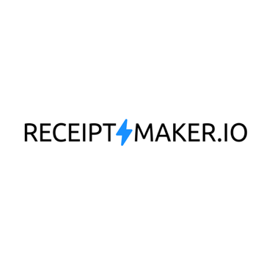

RECEIPT

NOTES:
SUB TOTAL | $0.00
DISCOUNT | $0.00
TAX (10%) | $0.00
TOTAL | $0.00
AMOUNT PAID | $0.00

COMPANY NAME • 1234567890 • INFO@SITE.COM

